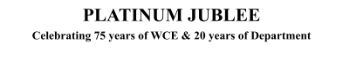

# Walchand College of Engineering, Sangli

***(Government Aided Autonomous Institute)***

Department of Information Technology

Computer Networks Lab

EVEN SEMESTER AY 2021-22

*Submitted by*

Name: Om Gharge

PRN: 2020BTEIT00041

Batch: S2

Course Code: 5IT272 Date: 25/05/2022

Contact Number: 9730369761

**Department of Information Technology**

2021-22

**Experiment Number:** 5

**Experiment Name:** Implement DHCP, WEB and DNS server in CISCO packet tracer and observe .

1. Auto IP configuration through DHCP server.
2. WEB server access through browser on host machine.
3. DNS server to name the WEB access.

# Contents:

**Problem Statement:** Implement DHCP, WEB and DNS server in CISCO packet tracer and observe.

* 1. Auto IP configuration through DHCP server.
  2. WEB server access through browser on host machine.
  3. DNS server to name the WEB access.

**Platform :** CISCO packet tracer

**Devices Required :** PC , Switch (2960-24TT), Router (1), Server.

**Design :**

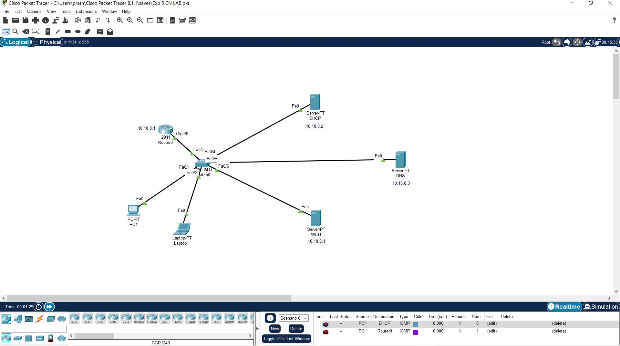

**Implementation :**

1. Create the topology as shown in the above image.
2. After creating the topology configure the network

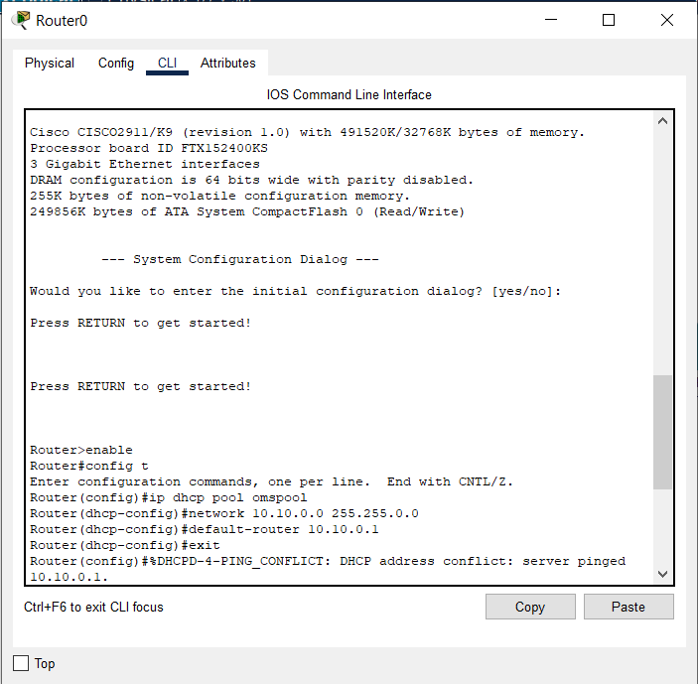

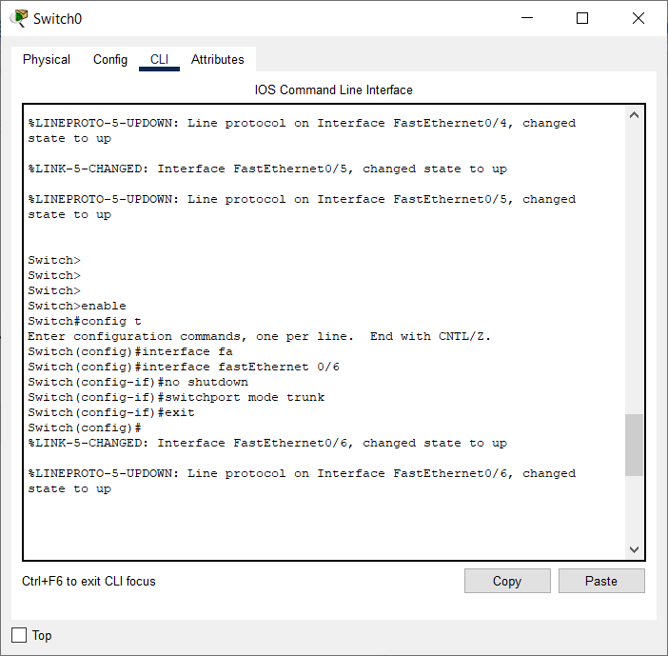

1. Configure all the three servers by giving them IP, Subnet and DNS
2. For the DHCP server turn on the DHCP and give the ip pool, starting ip and subnet mask.

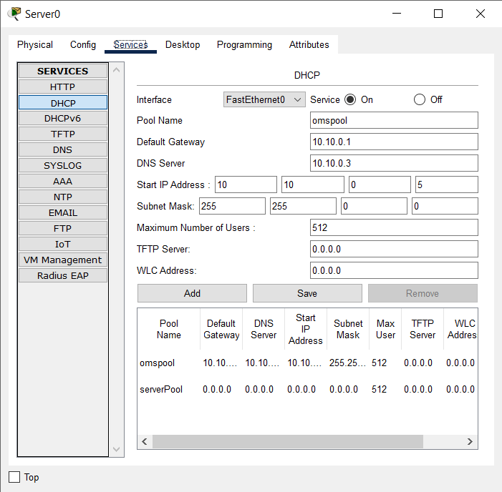

1. Enter the DNS for each http request by giving the address as ip

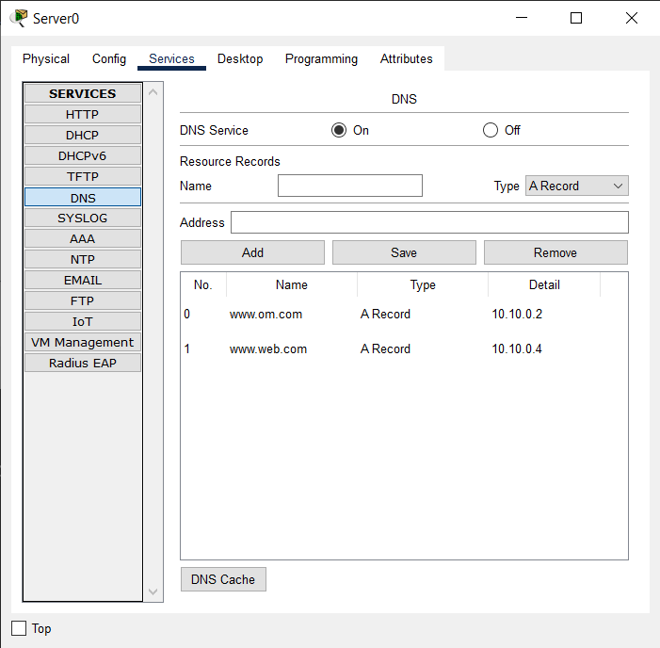

1. Edit the WEB index.html page and add your customization.

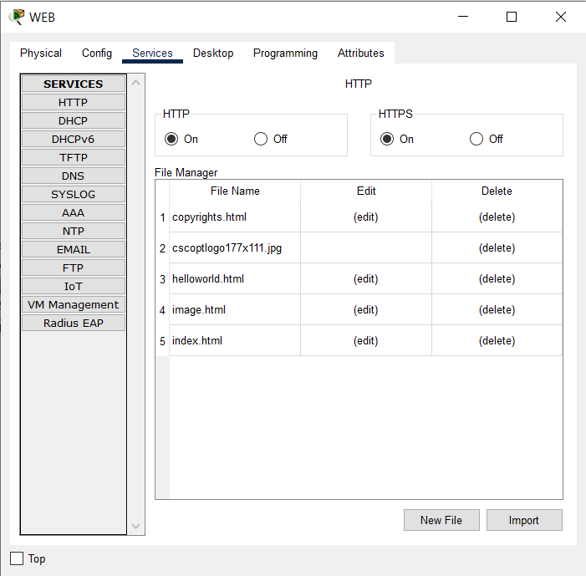

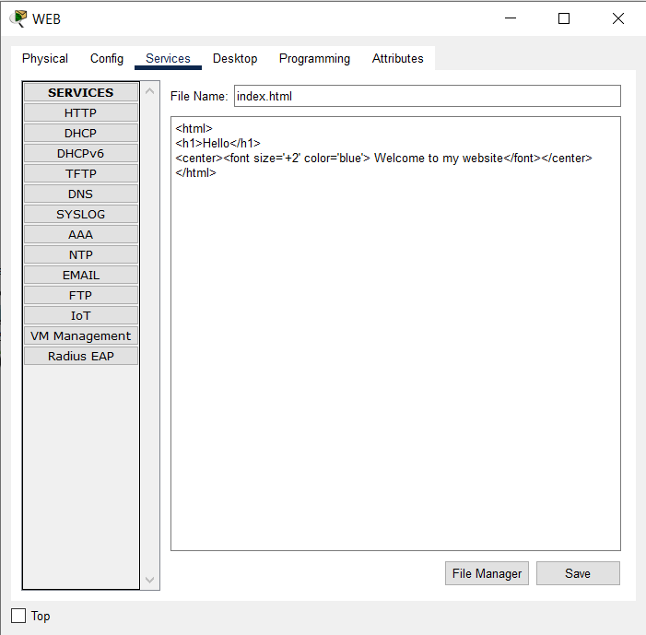

iv) Now enter the DNS you entered in the DNS server of the web browser.

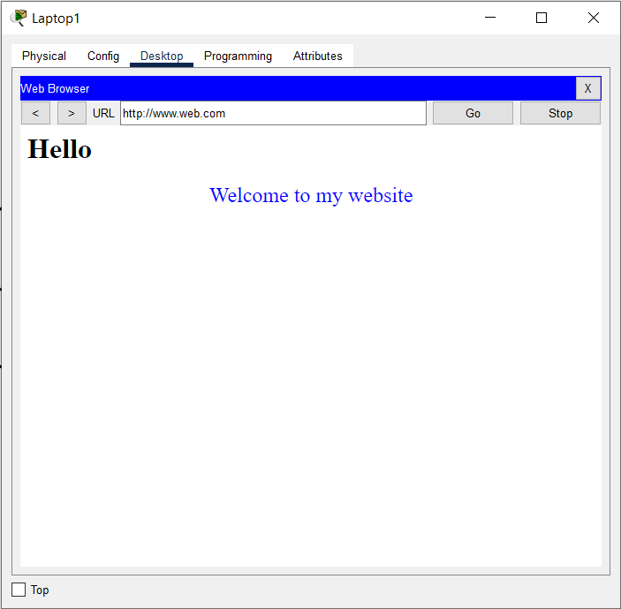

**Results:** DHCP, DNS and WEB (HTTP) works together to get the internet going well.

